**LAB_EXERCISE RIYA INDAP,44**

1.Write an interactive pearl script to convert temperature from centigrade to fahrenheit

Code:

#!/usr/bin/perl

print "ENter temperature in centigrade:";

$cent = <STDIN>;

$fah =(9* $cent/5)+32;

print "corresponding temperature in fahrenheit is $fah degree Fahrenheit";

output:

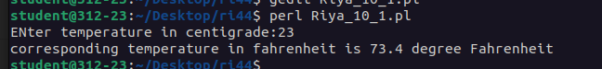

2.Write a perl script to compute the power of a given number

code:

#!/usr/bin/perl

print "Enter a number: ";

$num = <>;

print "Enter the exponent: ";

$exp = <>;

$pow = $num ** $exp;

print "The power of is = $pow\n";

output:

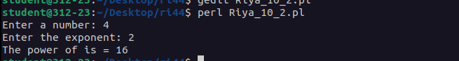

3.Write a perl script to check whether the entered number is prime or not.

code:

#!usr/bin/perl

print "Enter a number:";

$num=<>;

$flag=0;

for($i=2;$i<$num;$i++){

$div=$num % $i;

if($div==0)

{$flag=1;

}

}

if($num==1){

print "Is not a prime number";

}

else{

if($flag==0){

print "Entered number is a prime number";

}

if($flag==1){

print "Entered number is not a prime number";

} }

output:





**POST-EXPERIMENT**

1.Write a pearl script to check whether the year is leap or not

code:

print "Enter a year:";

$year=<>;

if(($year%4==0 and $year%100!=0) or $year%400==0){

print "Entered year is leap year";

}

else{

print "Entered year is not leap year\n";

}

output:

